Price per person/ night, breakfast included  - In a quad room without bath room €26,00  - In a triple room without bath room €26,00  - In a double room without bath room €31,00  - In a single room without bath room €37,00  - In a double room with bath room €37,00  - In a single room with bath room €47,00  Breakfast is served everyday from h. 7.30 a.m. to h. 9.00 a.m .on the second floor. It is reduced on Sundays and holidays in a self-service served from h.8,00 a.m. to h. 9.30 a.m. on the ground floor-Telephone Room.  The Guests of YWCA are kindly asked to observe the following regulations:  - on the day of departure, please leave your room before h. 10.00 a.m. and take your baggage downstairs  - please, anticipate your bill at your arrival  - if you stay more than one week, you have to pay the yearly card as “participant” member (cost € 10,00)  - after h. 11.00 p.m. and before h. 7.00 a.m. please do not use shower or engage in activities which might disturb or prevent others from having a quiet and restful night  - It is really prohibited smoking, to use electric stoves and kettles in the room. |  | Reservations  A deposit of the 30% of the total amount is required to  confirm a reservation by:  - an international bank cheque in Euro sent by  mail to our address:  Y.W.C.A.-U.C.D.G.  Via Cesare Balbo, 4  00184 - ROME  ITALY  - an international transaction: bank transfer to  Y.W.C.A.-U.C.D.G.  Via San Secondo, 70  10128 – TORINO  ITALY  BANCA SAN PAOLO – IMI (bank’s name)  Agency n° 524 – TORINO  Beneficiary account number: 5517  IBAN Code (International bank code ): IT61DØ1Ø25Ø1Ø241ØØØØØØØ5517  BIC CODE (Swift code to make the operations faster ): IBSPITTM  NB:ALL EXPENSES ARE TO BE CHARGED TO  THE SENDER.  Credit cards are not accepted

HOW TO REACH THE YWCA FROM THE TERMINI STATION

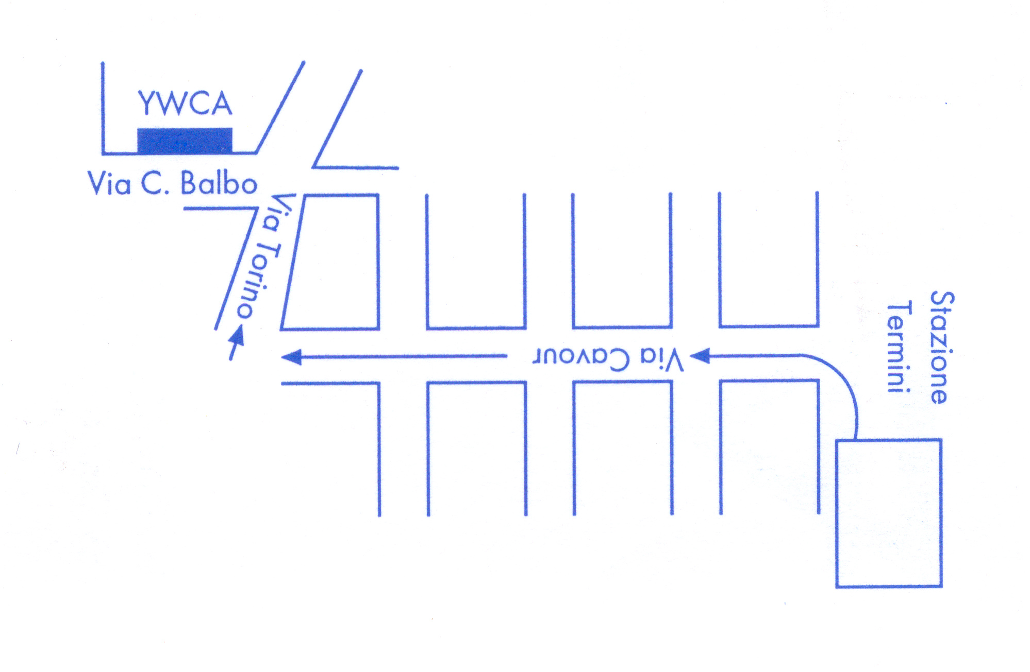

The House opens at h. 7.00 a.m. and closeS at h. 12 p.m.

